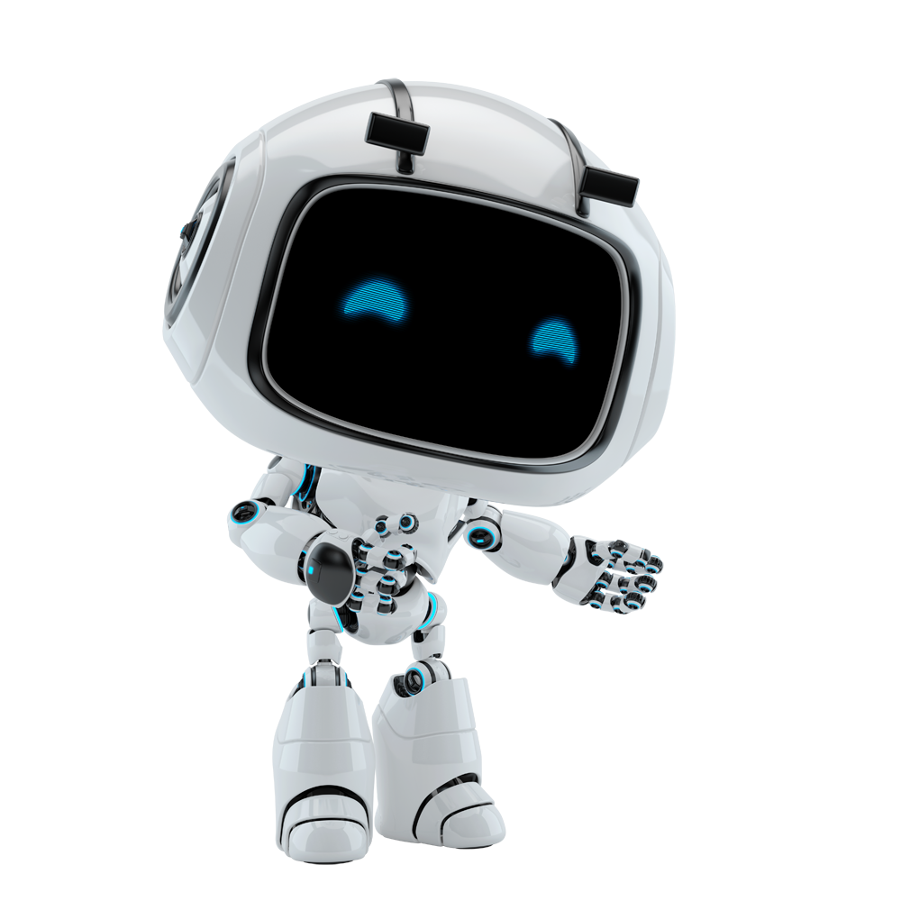

Art. 25 FLAG Management

UseCase #4: Art. 25 FLAG Management

Contents
Contents
1. Document Overview 4
2. Automated Master Project details 4
3. Runtime Guide 5
3.1 Runtime diagram [Architectural structure of the Master Project] 5
3.2 List of packages 6
3.3 Master Project Runtime details 7
4. Project details 8
4.1 Project Name: {Art. 25 FLAG Management} 10
5. Post UAT specifications 12
6. Glossary 13

Document History

Date | Version | Role | Name | Organization | Function | Comments
2-Feb-2026 | 1.0 | Developer | Ashish Mani Tripathi | Adecco Italy | Developer | Document revised v 1.0

Document Overview

The Development Specifications Document (DSD) is created for every business process that is automated using RPA technology. The DSD document needs to be reviewed and updated for every change requested and applied to the automation process. This document will provide a technical snapshot and must always reflect the latest design and key features of the automated workflow.
The document naming convention will follow the naming convention and the version of the automated process. This can be “business process name version” or it can be defined, case by case, as part of the larger RPA project design.
This document is filled in by the RPA Solution Architect and RPA Developer who automates the business process and reviewed by the RPA Solution Architect prior to handover to RPA Operations.
The purpose of the document is to record the outcome specific to the automated project and its subcomponents: projects, workflows, sequences etc.
This document is meant for the RPA COE, IT Support and RPA supervisor to help by providing a snapshot of the automated process details and components. It can as well serve developers to have a quick glance at the setup, before diving into the code, to troubleshoot or update changes.

Automated Project details

Details filled in by the developer reflect the actual information for the project released for production.
# | Item | Details  (Fill in with free text. If not applicable, mark the field as “n/a. No empty fields.)
1 | project name and version | Art. 25 FLAG Management
2 | Robot type  (specify if the process was automated for FOR or BOR or mix) | Unattended bot
3 | Is Orchestrator used? (Yes/ No) | yes
4 | Scalable? (Yes/ No)  (can the process be run by multiple robots in parallel) | yes

Runtime Guide

Runtime diagram [Architectural structure of the Project]

Display the interaction between components (package / robots, Orchestrator queues, and running
order).

Add diagram below:
We will use Dispatcher /performer Architecture to read data from the input file in dispatcher and process the data from performer.

Dispatcher Architecture

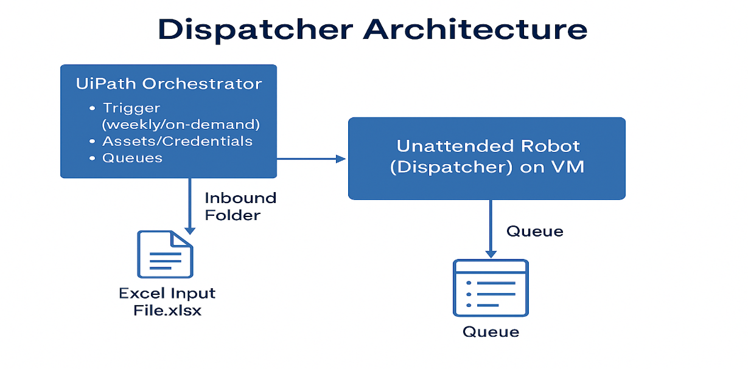

Performer Architecture

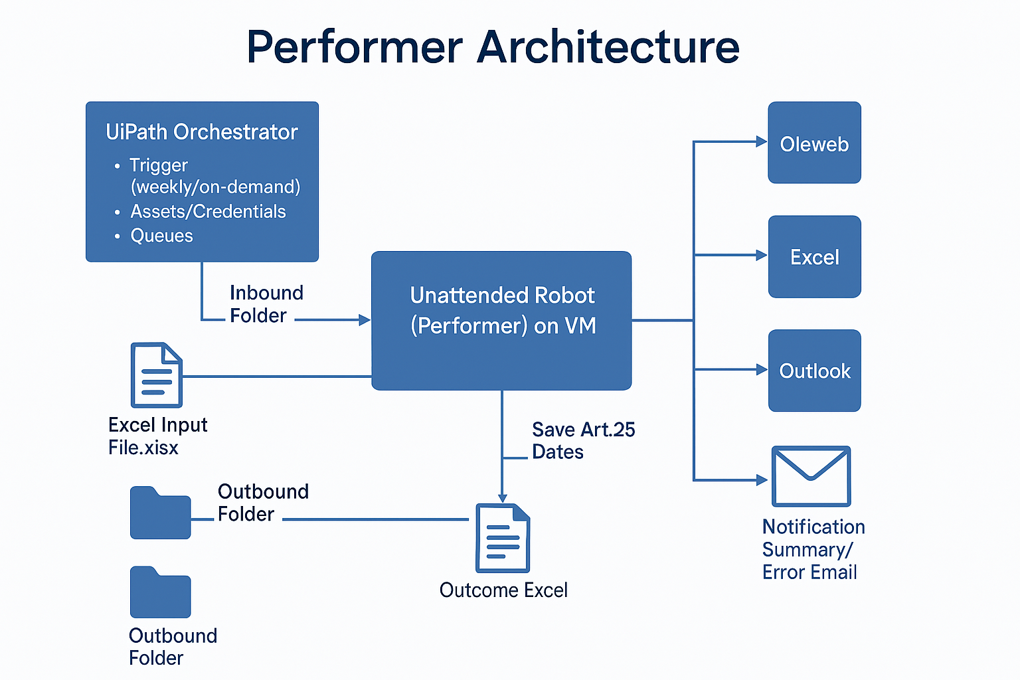

List of packages
Include the list of packages and the high-level description for each of them, to explain each one`s purpose: (Need to add Mail package and mention the package version as per the UiPath studio)
# | Package name | High Level description
1 | 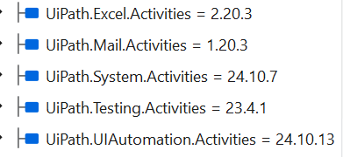 | Excel automation  Web automation  Mail automation
2
*Add more rows to the table to include all the project names and versions. No fields should be left empty. Use “n/a” for the items that don't apply to your project.

Project Runtime details

Details of the automated process:
# | Item | Details  (Fill in with free text. If the section does not apply to your automation, mark the field as “n/a”. No empty fields. )
1 | Production environment details | To be filled
2 | Prerequisites to run | - Uipath Assistent need to be Install in all environment VM  - Process folder need to be created in orchestrator(UAT/Prod/Test)  - Robot should assign to the process in orchestrator  - Share Drive should be accessible in all the VM  - For the input file.  - OleWeb Application must be accessible in UAT, Pilot, Prod VM  - Uipath Extension must be enable for the respective browser which will be use for Oleweb  - Office 365 should be install on the VM’s
3 | Input Data | Excel input data
4 | Expected Output (output data) | Excel output data
5 | How do you start the automated process? | triggered/scheduled.
6 | Resuming the process from a particular step
7 | Reporting  (queues reporting, Kibana or another platform) | TBD
8 | Manual Error Handling  (roll back or manually complete failed transactions). Procedures to reset the item. Ex “set status as investigating” | Check the failure cases at the end of the process
8 | 8 a. How to resume the process in case of error | The bot will continue to process the next transaction if any system/business exception occurs after updating the status of queue item. For system exception bot will retry the queue item as per defined retry value
8 | 8 b. How to manually fix transactions with error | After reviewing the log, I’ll decide how to proceed.
9 | Use of Orchestrator | Deploy package in orchestrator to run the process, Assets, Scheduling, Queue
9 | Password policies  (specific compliance requests?) | Store in Assets
9 | Stored Credentials:  (Never hardcode credentials in the workflow) | Password will be store in Key vault and credential type asset in orchestrator
9 | List of Asset Names:  (Follow naming convention ProcessName_AssetName) | IT_OLE_Art25FLAGManagement_OleWebCredencial  IT_OLE_Art25FLAGManagement_MailToSender
9 | List of Queues Names  (Follow naming convention ProcessName_QueueName) | IT_OLE_Art25FLAGManagement
9 | Schedule details: | - When the client sends an email, the bot will be triggered automatically.  - TBA
10 | Multiple resolutions supported  (in case of image automation/ Citrix) | NA
10 | Recommended resolution | NA

Project details

For the TI workers hired by Adecco since at least 6 months and without any associate contracts at least for 15 days, the user downloads a query from Microstrategy, then to grant the correct information for Art. 25 activation, branch users manually get the data from ft.web and insert it in Olè.
 | Item name | Details
1 | Environment used for development  (name, location, configuration details etc.) | UAT server Name- NTAZUEU21529  Server Login ID - Ole.RPA-IT_UAT  Development folder location- C:\RPA\IT_OLE_Article25FlagManagement
2 | Environment prerequisites  (OS details, libraries, required apps) | - Operating System: Windows 8.1,10, 11.  - .NET Framework:  - The UAT version of OLE web application needs to be accessible on a development platform with SSO login on a given account or provide UAT login/Password to login on the application.  - Uipath Studio should be installed
3 | Logging level | Info,Error
4 | Details about automation (if the apps were automated using UI Automation, Image & Text) | - Methods:  It uses selectors (e.g., HTML for web) to identify and interact with UI elements.  - Modern Approach:  Ui Automation will be done using UiPath Modern activities and classic activities if needed.
5 | In case of FOR, can the user operate the computer while the robot is running? | No
6 | Repository for project  (where the developed project is stored) | C:\RPA\IT_OLE_Article25FlagManagement” folder on VM
7 | List of reused components | NA
8 | Custom logs defined in the workflows  (where Throw Activity was used or custom log message was defined) | - Log will be used for any exception  - At any flow decision step  - Also, where applicable, like at the start and end of every transaction.
9 | Frequent errors found in the development phase | - TBA
10 | Workarounds used in the automation phase | TBA
11 | Configuration method  (assets, excel file, Json file) | - Arguments, Asset and Config file
12 | Configuration details  (path for input files, configuration Orchestrator assets used) | Orchestrator Folder Name- TAG/IT Italy/IT OLE

Project Name: {Art. 25 FLAG Management}

Workflow(s) specific to {Contracts Seniority Update }

Add to the title of this section the actual project name to which the workflows are specific to. The name should normally coincide with the Project name mentioned at Section 4.1
Define below all the workflow files ( xaml files) used in the project, with the Input and Output data.
# | Workflow file name | Description | Input Argument | Output Argument
1 | Main |  | in_OrchestratorQueueFolder, in_OrchestratorQueueName  In_ConfigFilePath, In_SharedDrivePath
2 | Process | Update the Value in oleWeb | in_TransactionItem, in_Config
3 | Login_OleWeb | Login into the oleWeb | In_Config
4 | Logout_OleWeb | Logout to the oleWeb
5 | CloseAllApplications | Close the application
6 | GetTransactionData | Passing the transaction to the process | in_TransactionNumber, in_Config, io_dt_TransactionData | out_TransactionItem, io_dt_TransactionData
7 | SetTransactionStatus | Set the status of the case | in_BusinessException, in_SystemException,  in_Config, io_RetryNumber,
8 | RetryCurrentTransaction | Retry process | in_Config, io_RetryNumber, io_TransactionNumber , in_SystemException, in_QueueRetry | io_RetryNumber, io_TransactionNumbe
9 | Modicification_FirstWindow | Fetch, Branch id, Contract ID, Month and year | In_BranchID, In_ContractItype,In_Month,
10 | CreateReport | Read Excel report | IN_QueueName, IN_OrchFolder
11 | SendReport | Send Excel Report to Business | IN_config
12 | InitAllSetting | Initialize, populate and output a configuration | in_ConfigSheets, in_ConfigFile | out_Config
13 | InitAllApplication | Open applications used in the process and do necessary initialization procedures (e.g., login). | in_Config | Out_UiElement
*Add more rows to the table to include all the workflow file names. No fields should be left empty. Use “n/a” for the items that don`t apply to your project.

Dispatcher
# | Workflow file name | Description | Input Argument | Output Argument
1 | Main | Main file of the dispatcher | In_SharedDrivePath
2 | ReadInputFile | Reading data into the datatable |  | Out_config
3 | CreateQueueItem | Adding data into the queue | IN_config
4 | ReadAssets | Read input file path | IN_config

Post UAT specifications

Average duration per transaction: (2 min approx) :
Recommended number of robots for the specified volumes:TBD
Specified schedule: TBD

Glossary
project - the overall output of the development, containing one or multiple projects that together cover the scope of the robotic process automation.
Project - an UiPath Studio project containing one or multiple workflow files. A project can be converted to a package and run independently, covering a particular scope within the project. The project is used when defining the development and support phase of the automation.
Package - the output of compiling a project. A package can be deployed on the robot machine and be executed by the robot service. Only one package can be executed at a given time by a robot. The package is used when defining the running phase of the automation
Workflow - a component of the package, the workflow encapsulates a part of the project logic. The workflow can be of type: sequence, flowchart or state machine. a workflow is saved as an .xaml file inside the project folder. A workflow file can be invoked from another workflow and by default there is an initial workflow file that will run when executing the package.
Activity - an action that the robot executes.
Sequence - a workflow where activities are executed one after another, in a sequential order
Flowchart - a workflow where activities are connected by arrows and the logic of the workflow can be easily followed in a visual manner. The flowchart can also be exported as an image from UiPath studio
State machine - a more advanced way of organizing a workflow, similar to a flowchart.
BOR - Back office robot
FOR – Front office robot
Orchestrator – Enterprise architecture server platform supporting: release management, centralized logging, reporting, auditing and monitoring tools, remote control, centralized scheduling, queue/robot workload management, assets management.

